All AI interactions in the middle pane should draw context from the Personalization and Memories. As you can see here, it doesn’t.
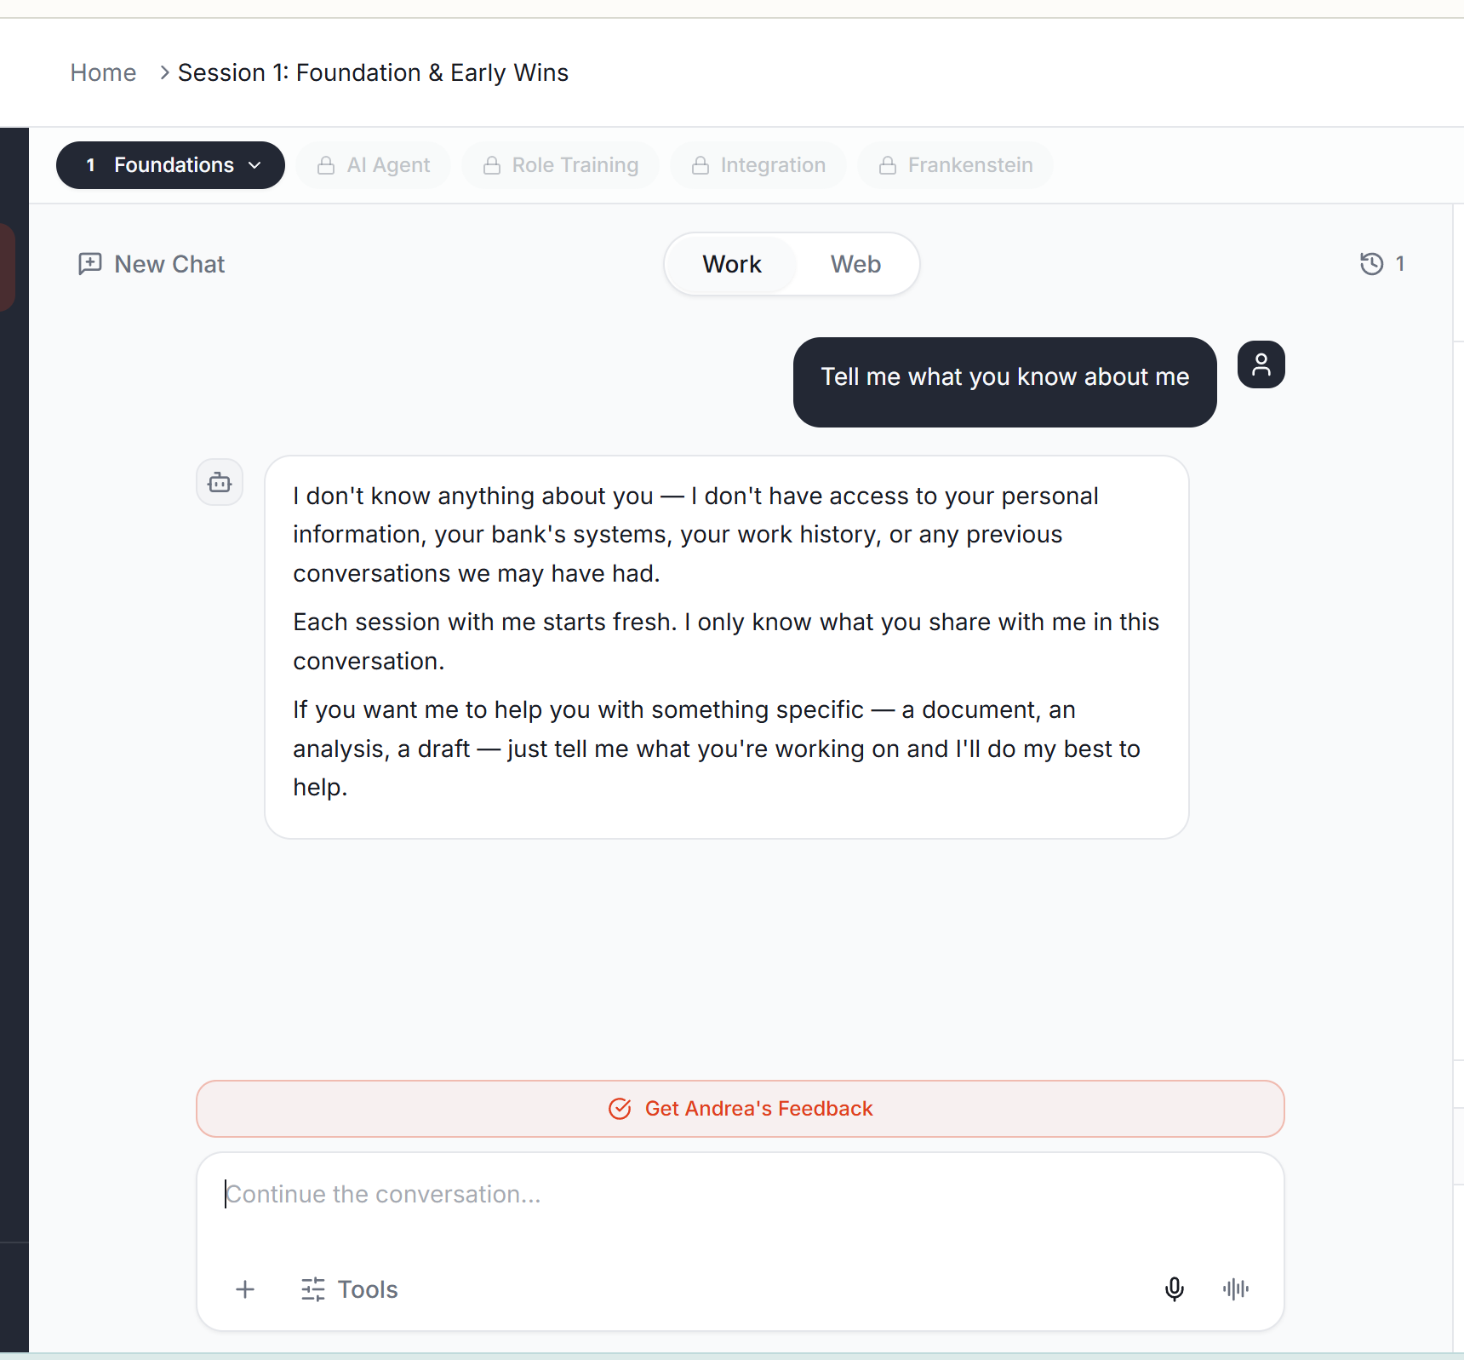
In all modules before they are taught/explained to the user, the functionality in the middle pane that are dead buttons. When clicking on the dead button, a small box should appear saying “This functionality will be available after the module where they are taught.”
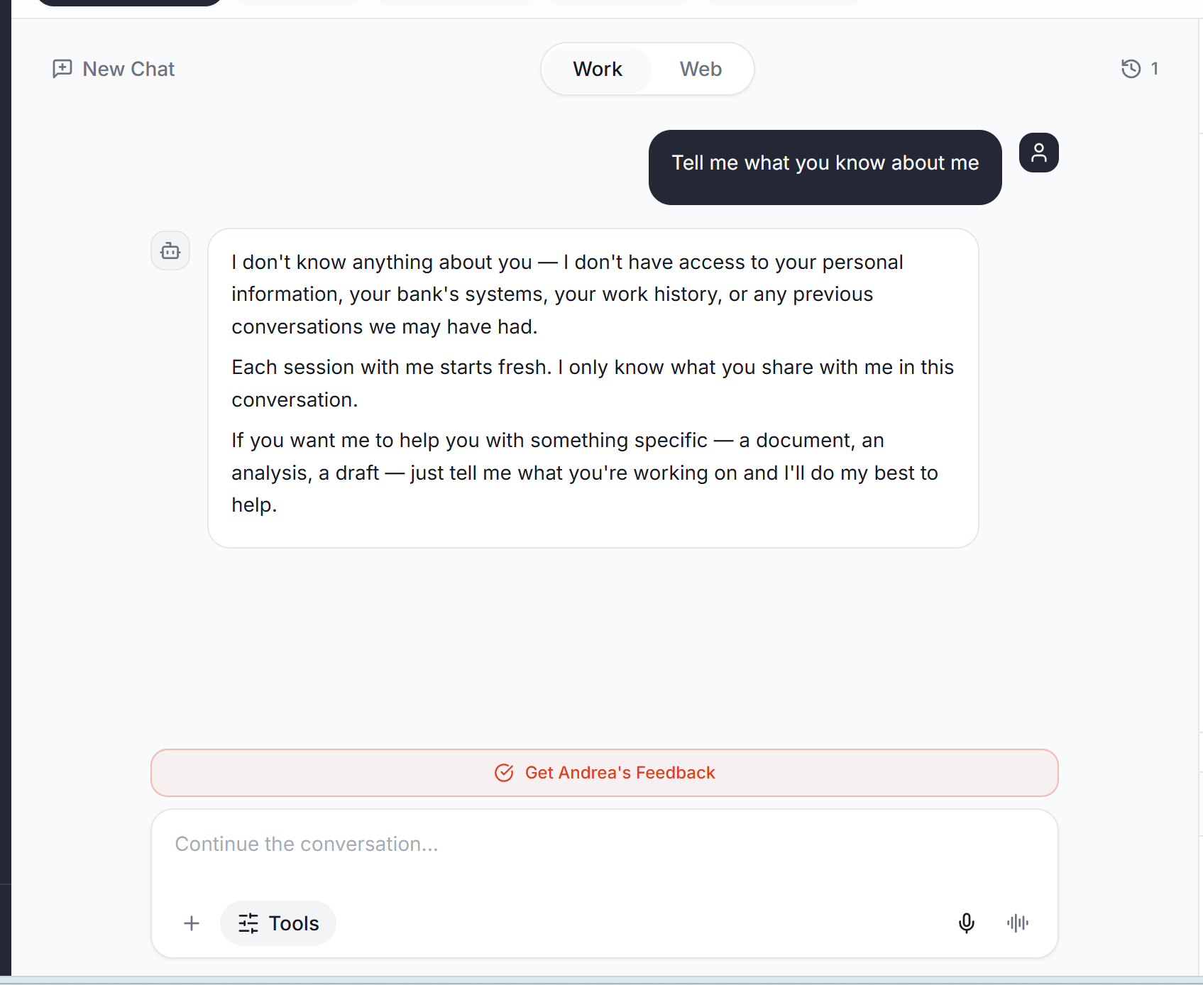
Every time I navigate away from the web app, the in process tasks that are running stop. For example, in the screen shot below, I provided a prompt, navigated away, and when I came back there was no response and AI stopped running. This goes for all of the web app, not just this middle pane. I think the issue is that the web app reloads every time you navigate away and come back.
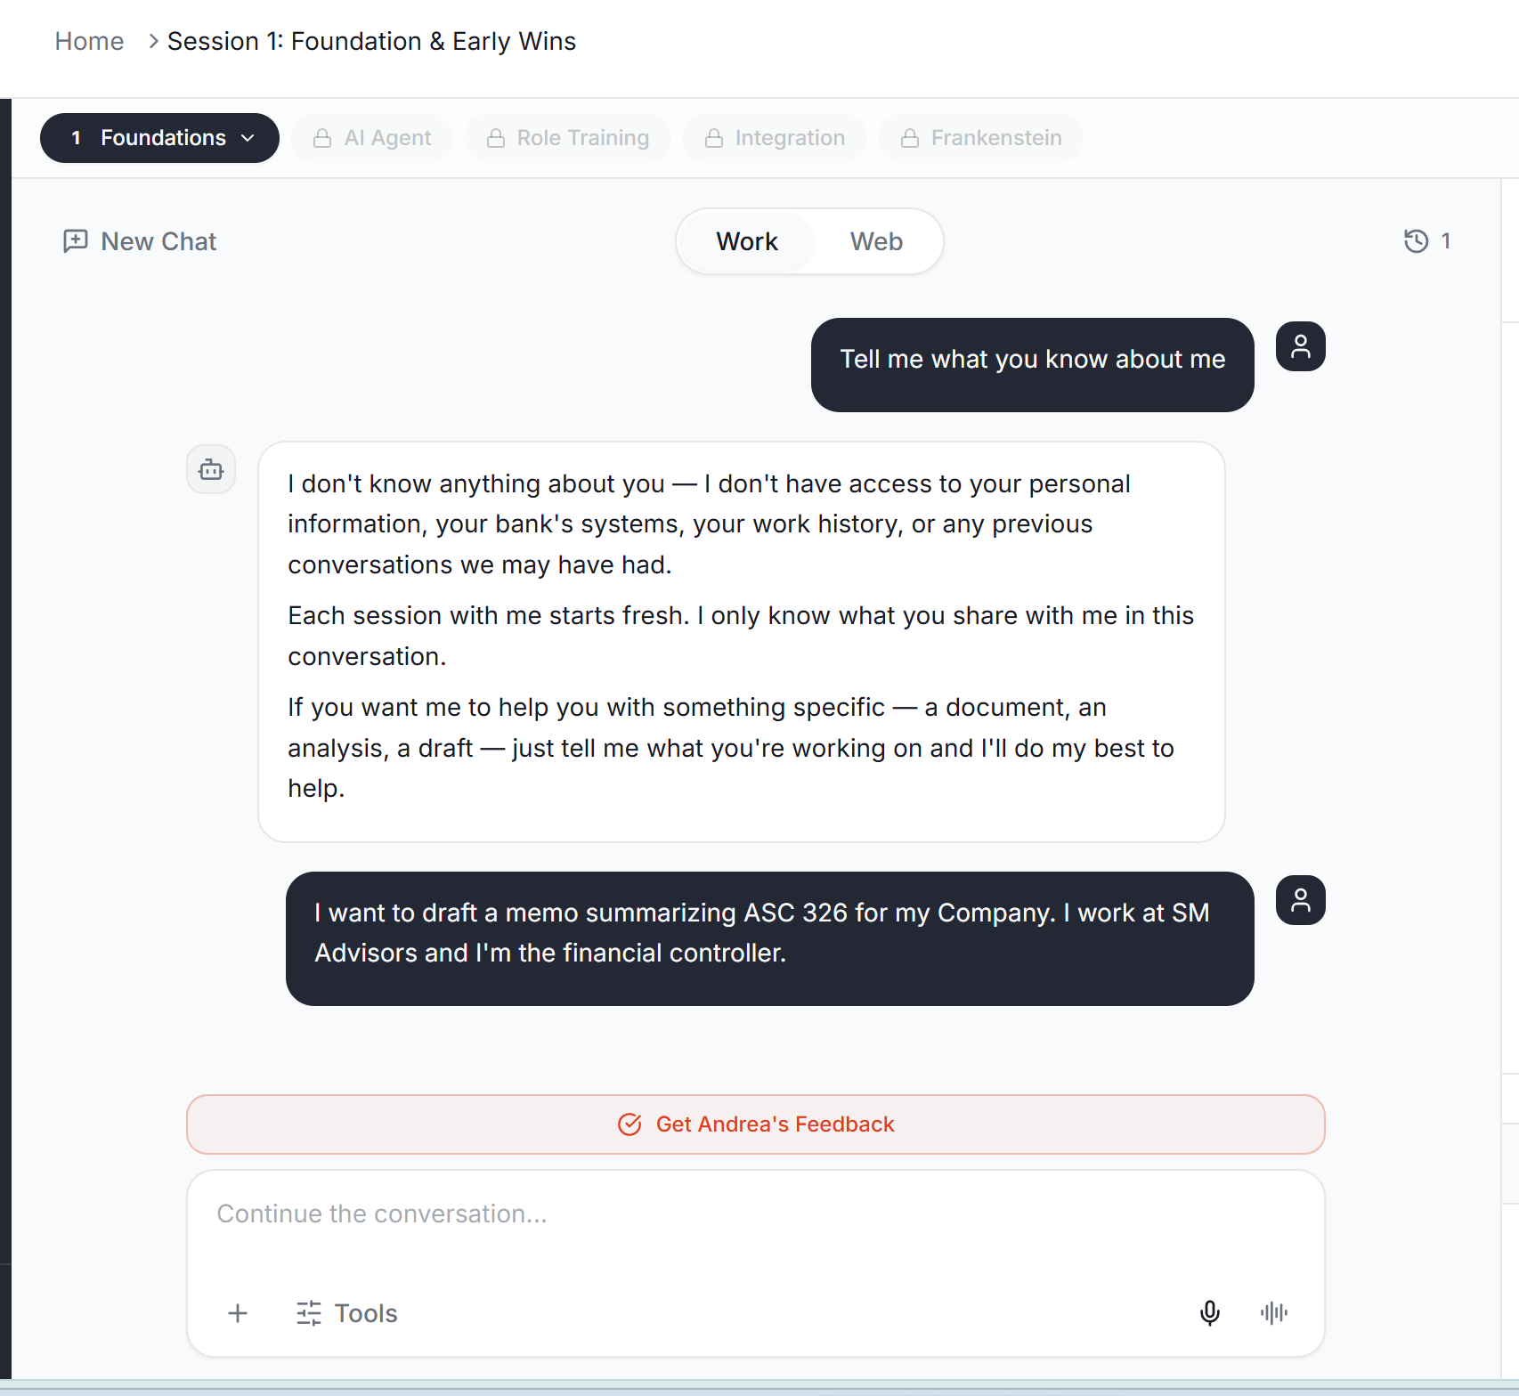
Is Andrea drawing on the users “Level” of AI skillset? She should be tailoring her responses to the AI skillset of the individual.
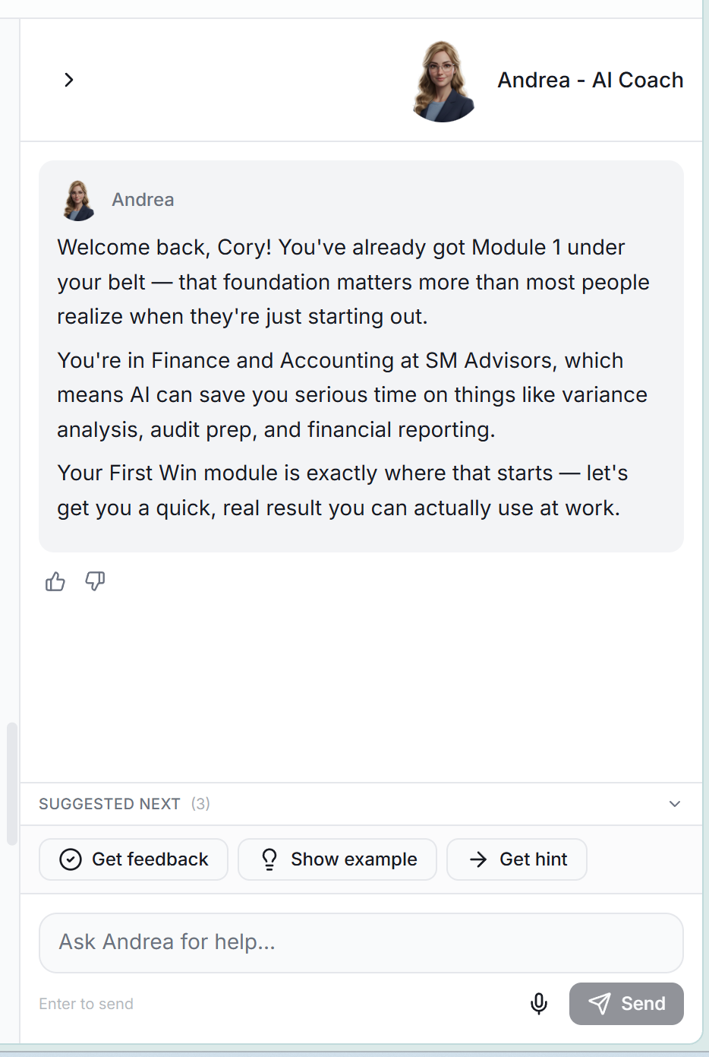

I’m in the first win module of Session 1. The issues that were noted here were not described as necessary to implement in this task. Andrea should only flag issues that are specifically driven by failing to apply the task criteria. All other items should be “Areas for Improvement” so that the user can read it, but still move forward in the platform.
*Note that this approach should be the same for all modules.
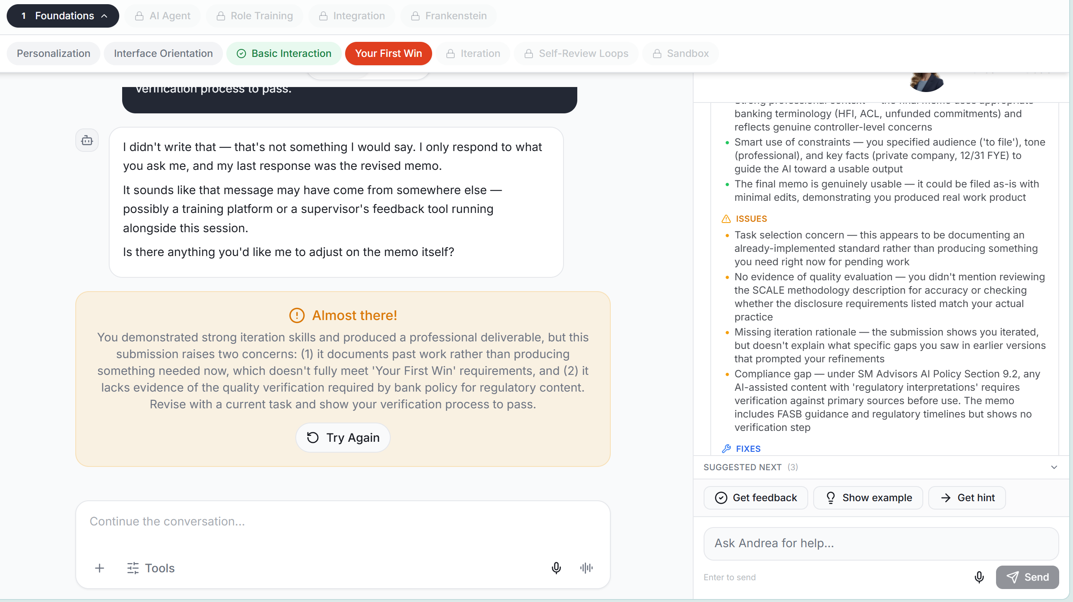
I’m getting this error in the main pane, but I don’t understand why. Andrea on the right is working, but there’s a connection issue on the left. I’m not sure if this is only a Session 1.4 issue, or if its more broad.
